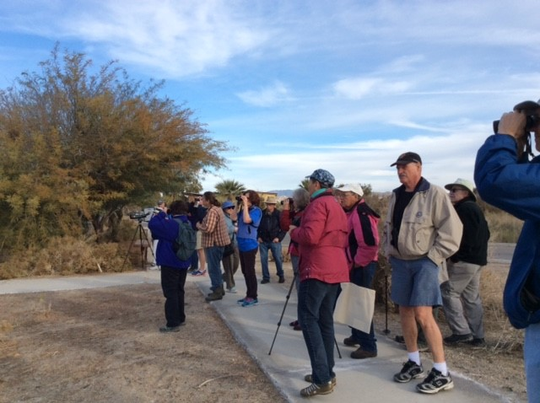

For More Information:

Call: SDIA 760-289-9455

Email: info@seaanddesert.org

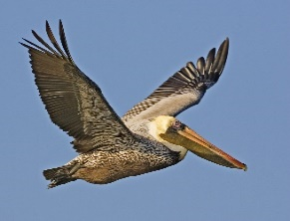
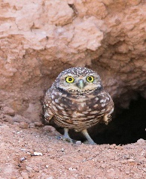

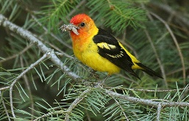
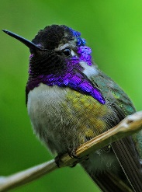

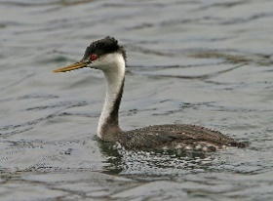
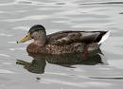

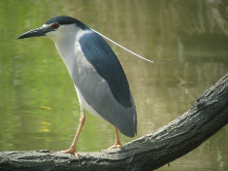
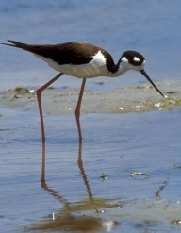

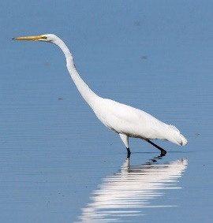

OVER 432+ SPECIES OF BIRDS
HAVE BEEN SEEN
WITHIN THE SALTON SEA REGION

SALTON SEA BIRD FESTIVAL

Schedule of Events

SATURDAY, JAN 13

7:00 AM - REGISTRATION– Check In
11:00 AM

8:00 AM SHORELINE BIRD WALK: Salton Sea Rec Area
with Matthew Salkiewicz

8:00 AM - NORTH TO SOUTH BIRDING TOUR
2:00 PM with KAREN NELSON
Salton Sea State Rec Area to
DONATION $25.00 Sonny Bono SS Natl Wildlife
Refuge (including Unit One)

10:00 AM IRONWOOD TRAIL WALK: Salton Sea Rec Area
with Matthew Salkiewicz

1:00 PM SHORELINE BIRD WALK: Salton Sea Rec Area
with Matthew Salkiewicz

SUNDAY, JAN 14

7:00 AM REGISTRATION – Check In

8:00 AM COACHELLA VALLEY WILD BIRD CENTER
with Karen Nelson & Matthew Salkiewicz

DONATION $10.00 – Proceeds will be given to the Wild Bird Center

12:00 PM - 1:00 PM SALTON SEA WILDLIFE UPDATE
Environmental Changes at the Salton Sea Bird & Fish Life
-Chris Schoneman, Project Manager
Sonny Bono SS National Wildlife Refuge

1:30 PM - 3;00 PM SALTON SEA 10-YEAR PLAN
Where do we go from here?
-Bruce Wilcox, Assistant Secretary Salton Sea Policy
California Department of Natural Resources

NOTE:
Festival Registration does not cover State Park entry or camping fees.
These FEES must be paid separately to Salton Sea State Rec Area.
--There’s NO ATM within the State Park

Hope to see you all at the Event

